DAX Functions in Power BI Assignment

Tasks to be performed :
1. Create a calculated column totalprice using quantity and unit price.
Answer
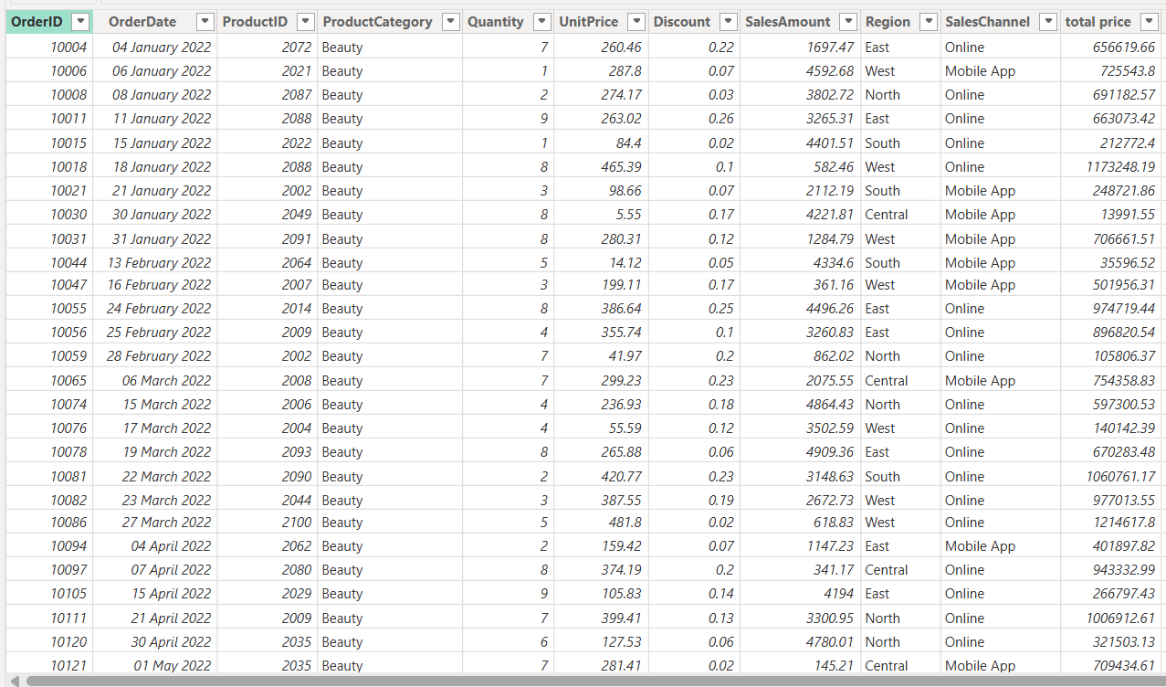

2.Create a calculated column DiscountedPrice.
Answer
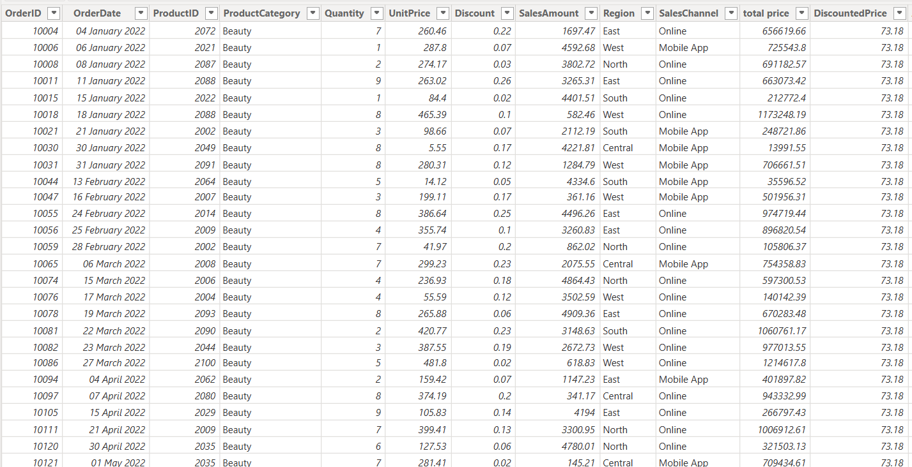
3.Create a measure Average Order Value (AOV).
Answer
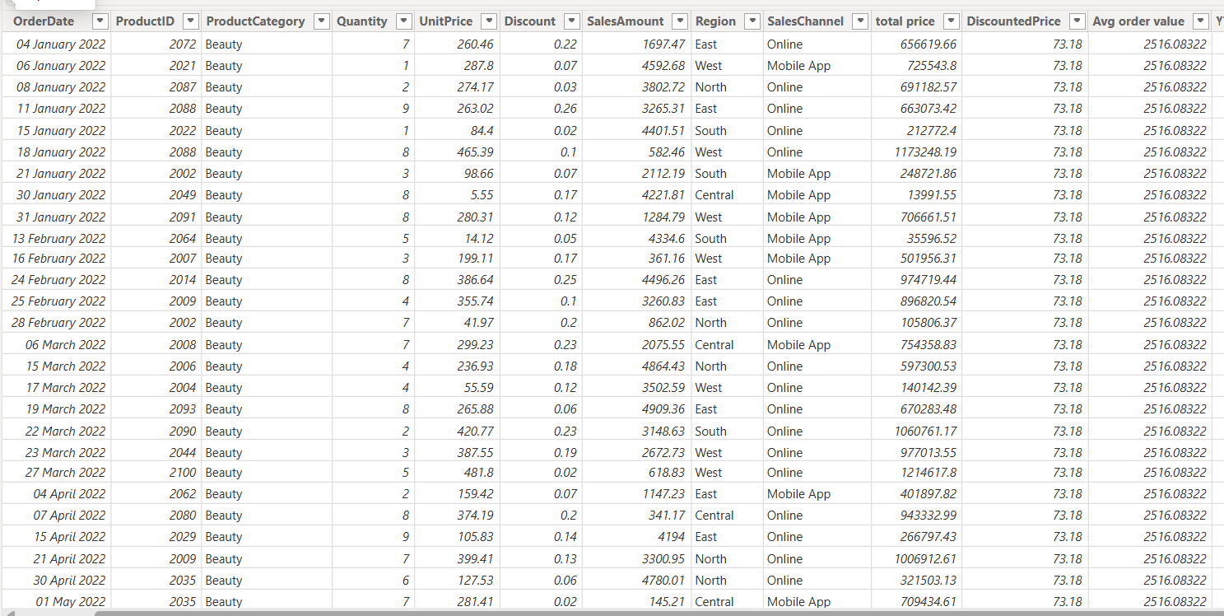

4.Using DAX, create a measure that calculates cumulative Year-to-Date (YTD) Sales based on the Order Date.
Answer
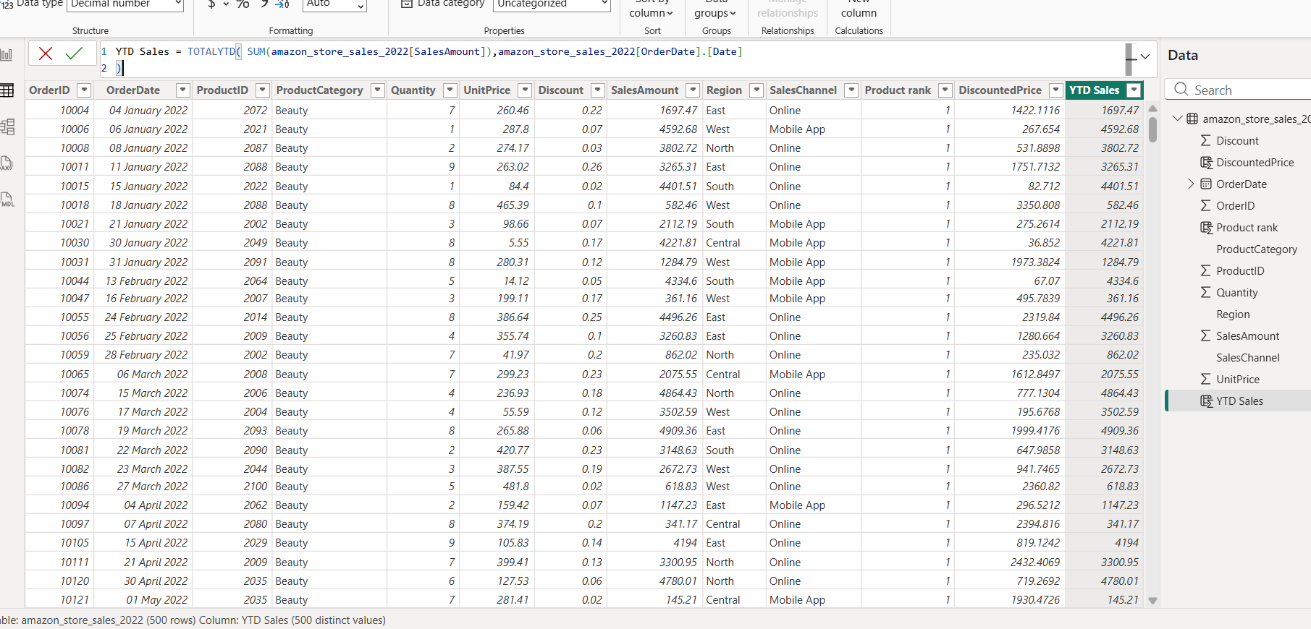

5.Using DAX, create a measure to rank each product according to its Total Sales, with the highest-selling product ranked first.
Answer
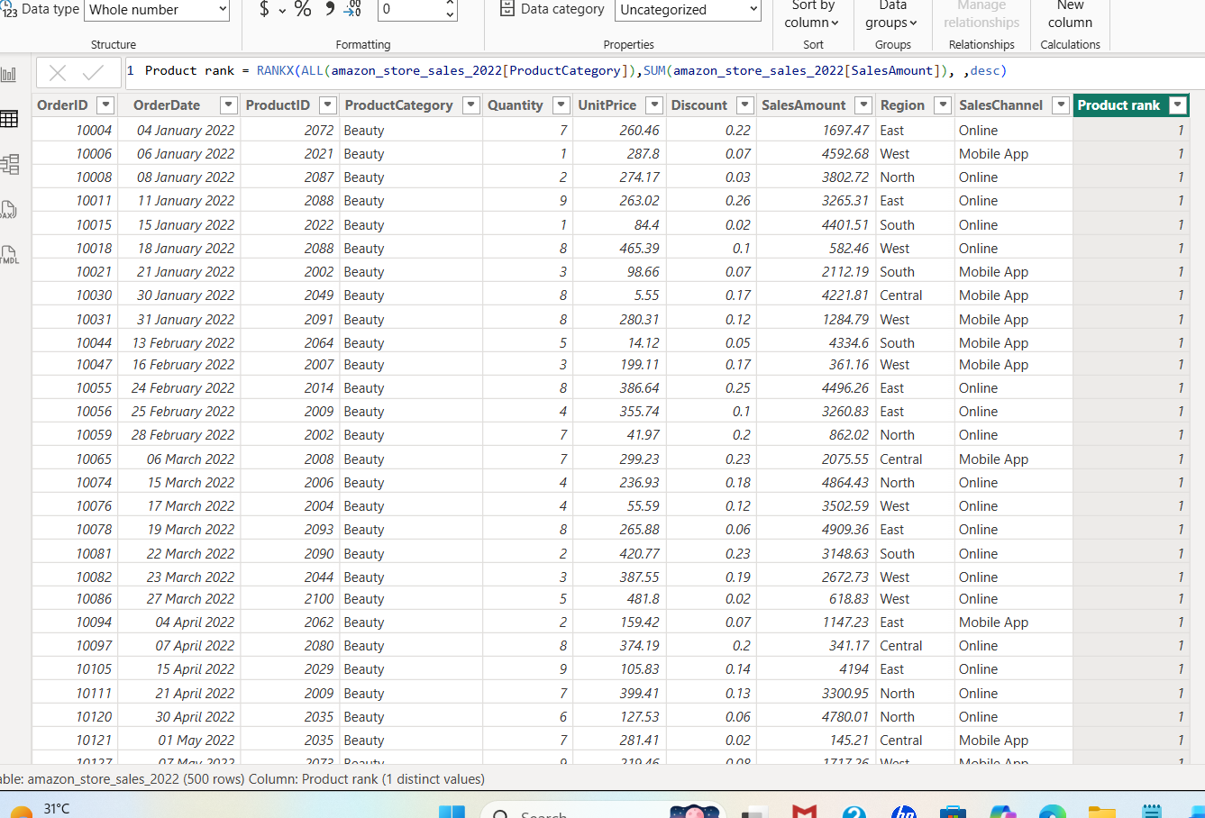

6.Create a calculated column classifying orders as “High Value” if sales > 2000, else “Low Value”.
Answer
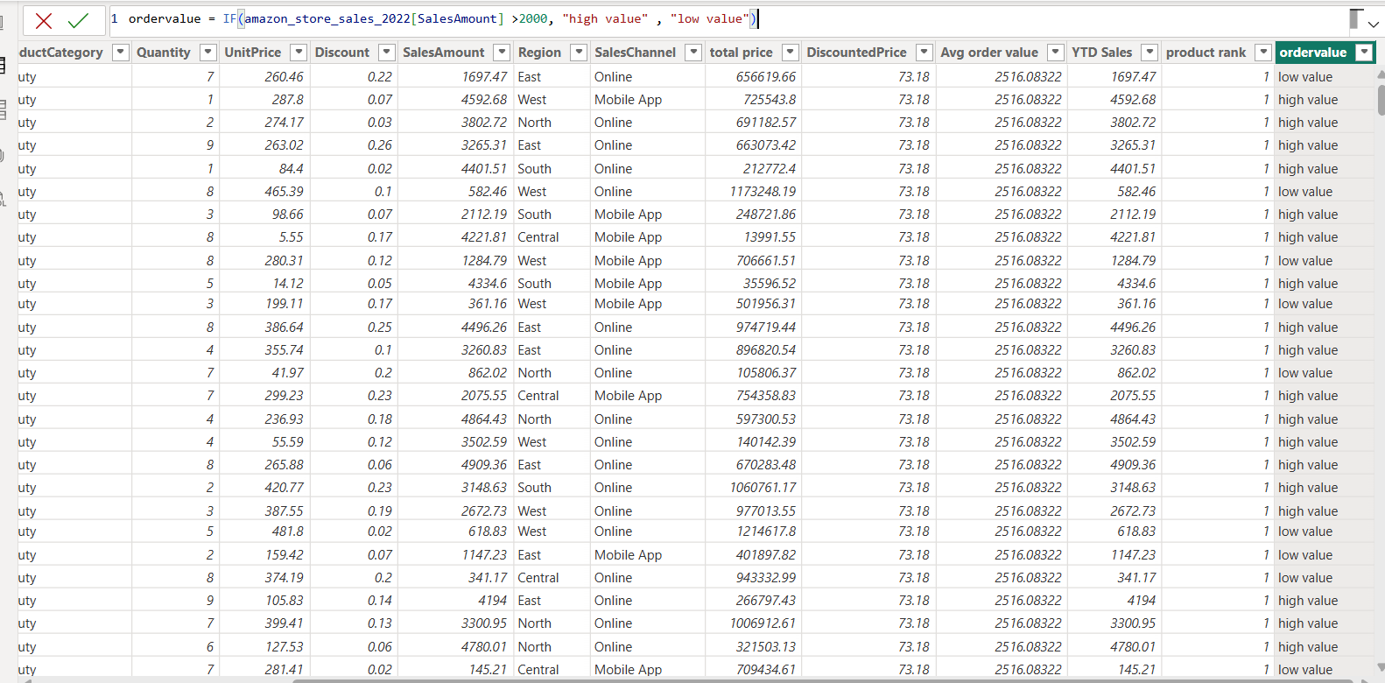

7.Create a measure to calculate total sales from the Online channel only.
Answer
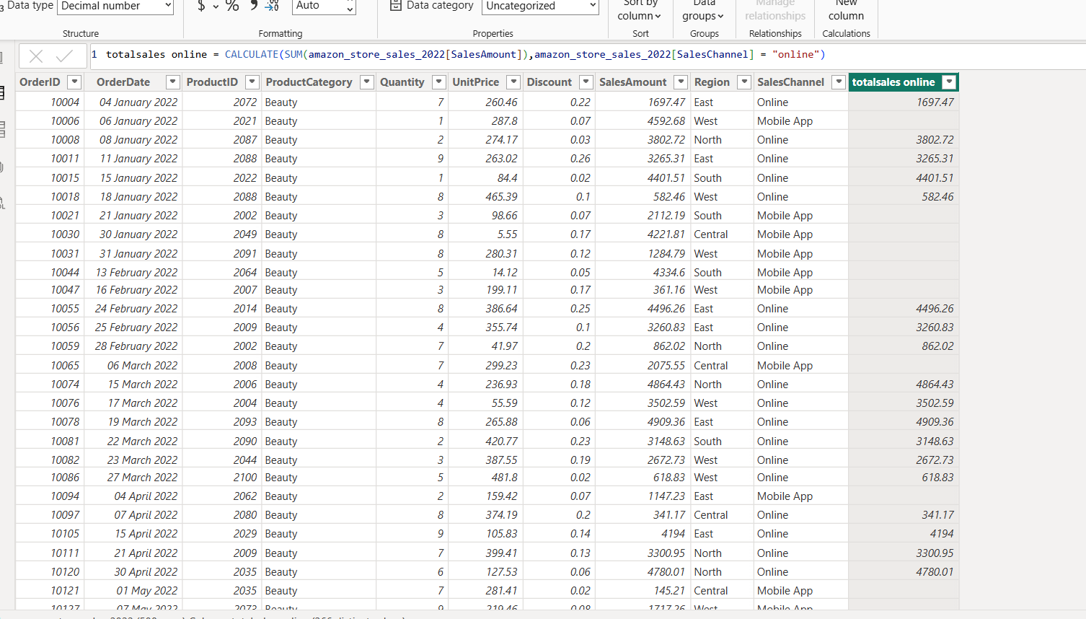

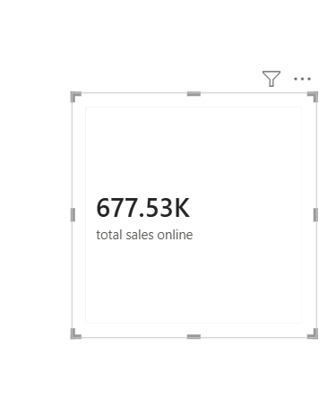
8.Create a measure called "Date Difference" that calculates the number of days between the latest Order Date and today's date using the DATEDIFF function.
Answer
